WEEK 1 TO WEEK 6 ASSIGNMENT VERSION 1
Contents
Week 1: Introduction to Mobile Application Development 2
Practical Activities Undertaken 2
Tools/Software Used 6
Personal Reflection 6
Week 2: Mobile Development Environment 7
Tools/Software Used 8
Personal Reflection 8
Week 3: User Interface Design 9
Designing in FIGMA 9
Data flow within the design 10
Tools/Software Used 10
Project coding and implementation screenshots 11
Personal Reflection 11

Week 1: Introduction to Mobile Application Development

Practical Activities Undertaken
only screenshots needed and labeling
Screenshots/Evidence Attached (Yes/No)
WEEK 1 ASSIGNMENT
Assignment 1
Students should:
- Install all development tools
- Create one Flutter app
- Change:
  - App title
  - Background color
  - Font size
- Submit screenshots and source code
- Creating the app
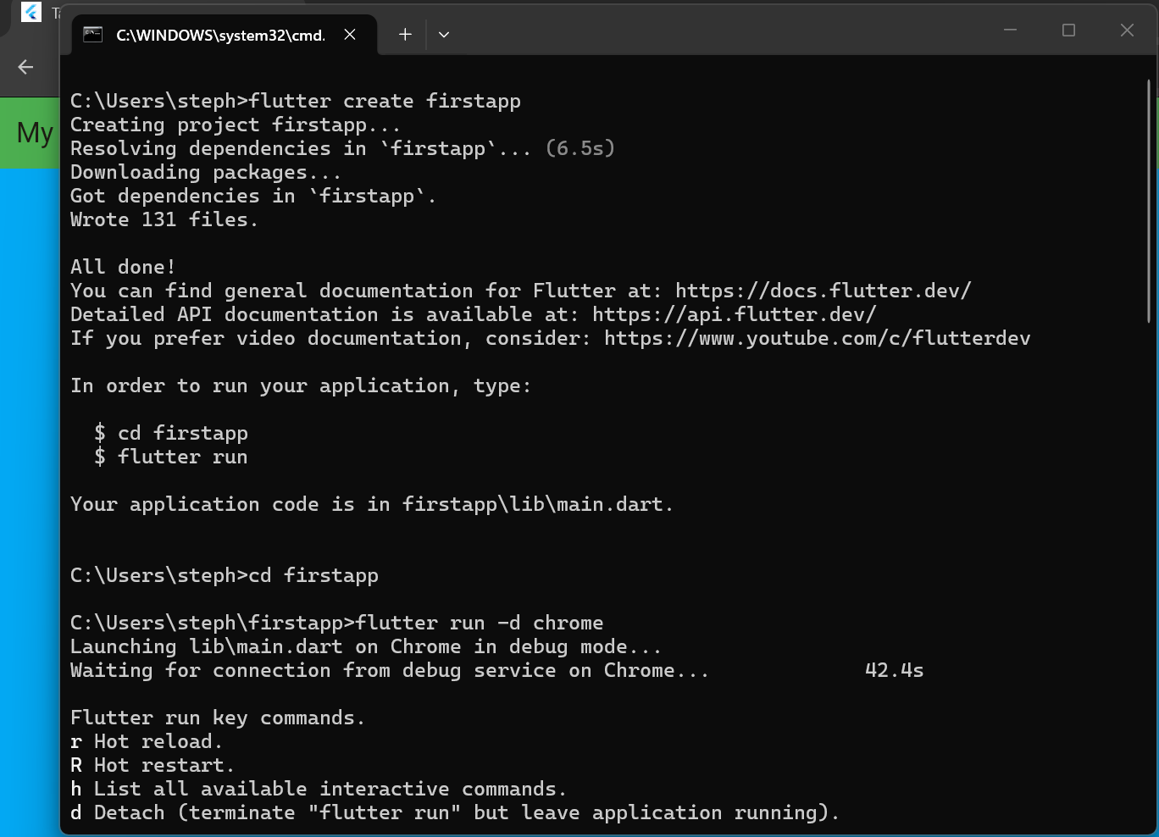

- Source code

- Running the project
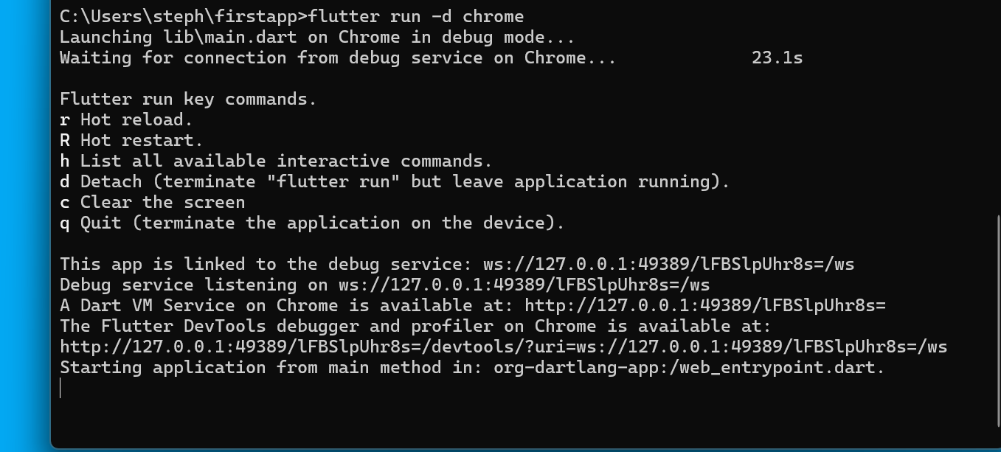
- The page
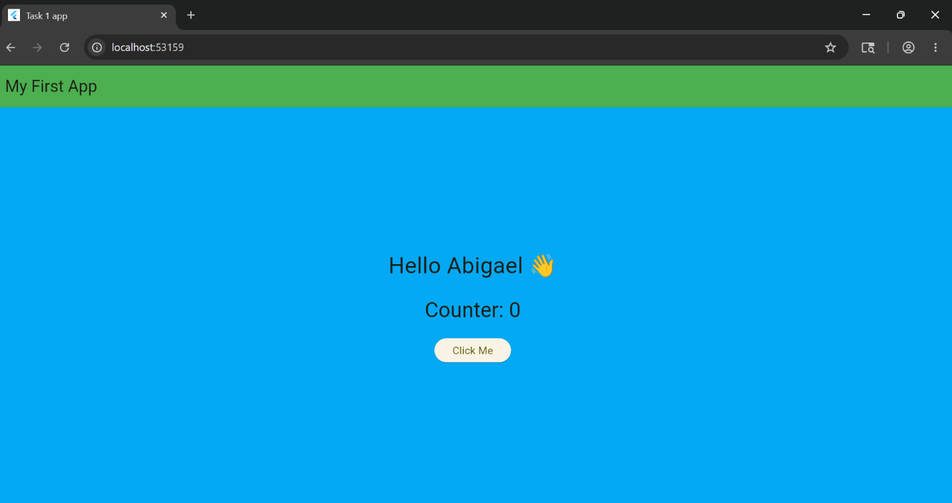
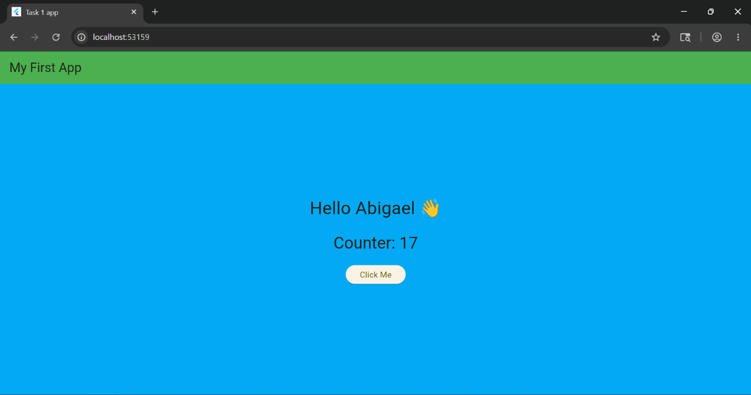

- Changed colors and font size

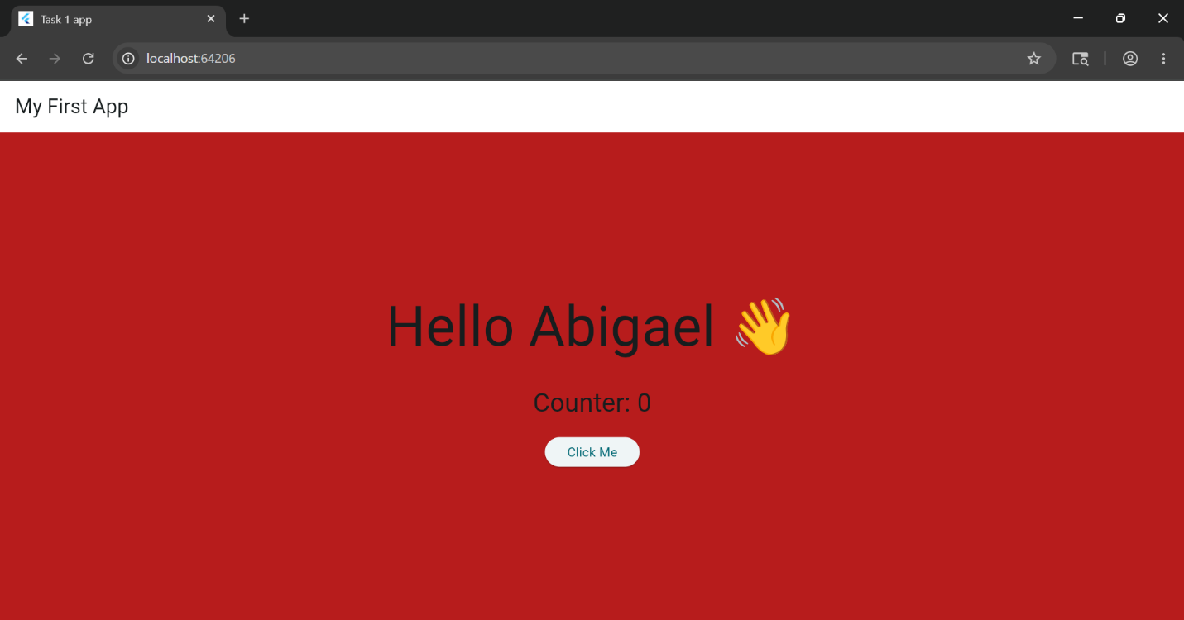
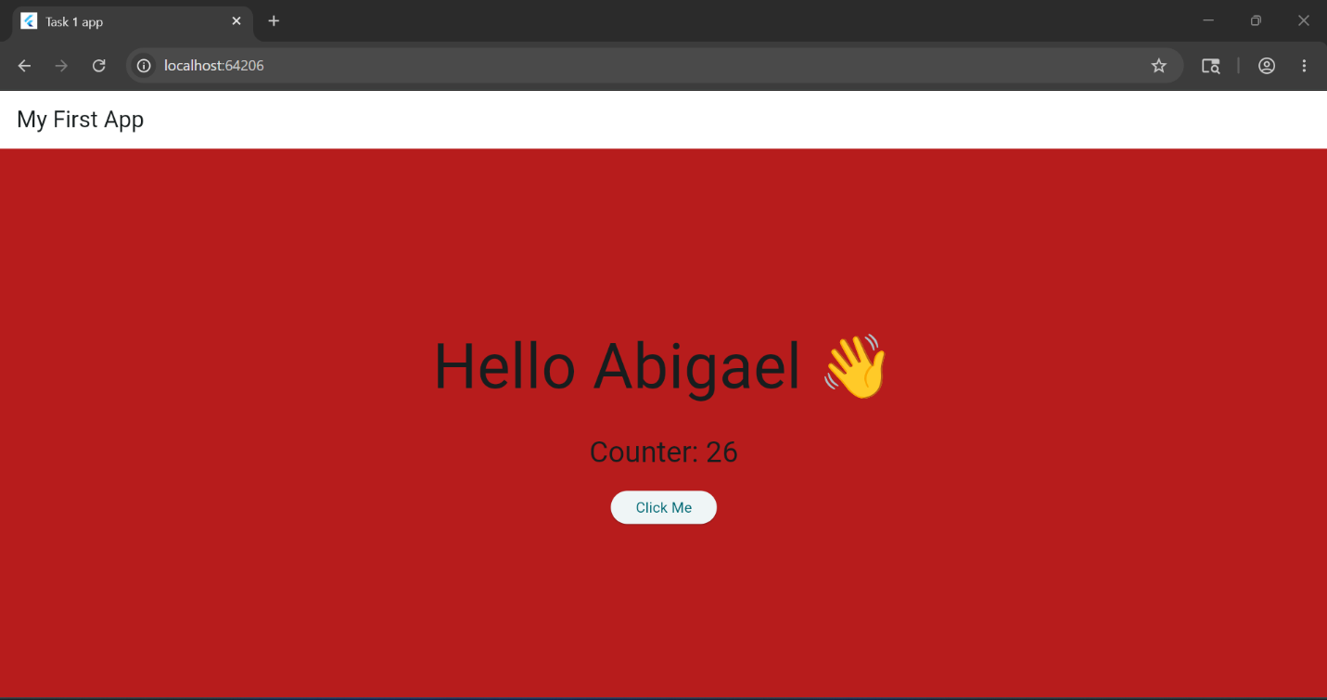

Tools/Software Used
    - Flutter
    - Chrome

Personal Reflection
My first week of learning Flutter was both challenging and exciting. As a beginner, I was introduced to the fundamentals of mobile application development, including setting up the development environment, understanding widgets, and creating basic user interfaces. Although I encountered some difficulties, the hands-on practice helped me develop problem-solving skills and build confidence in using Flutter. This experience laid a strong foundation for my journey in mobile app development.

Week 2: Mobile Development Environment
Work flow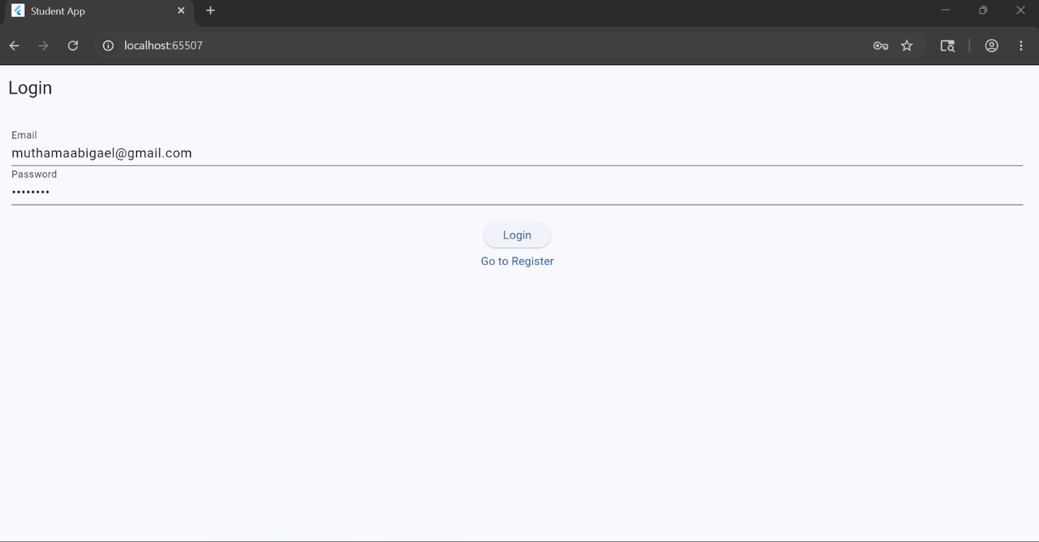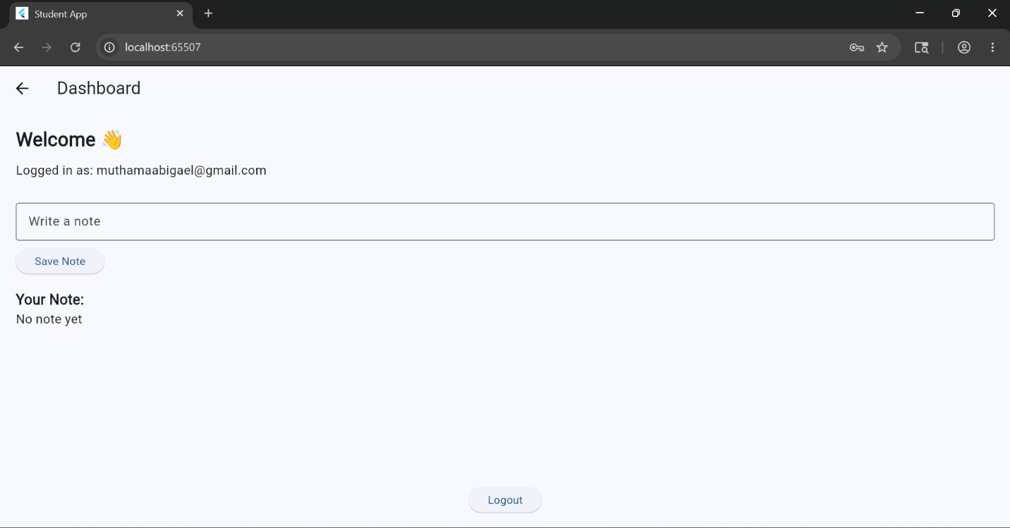
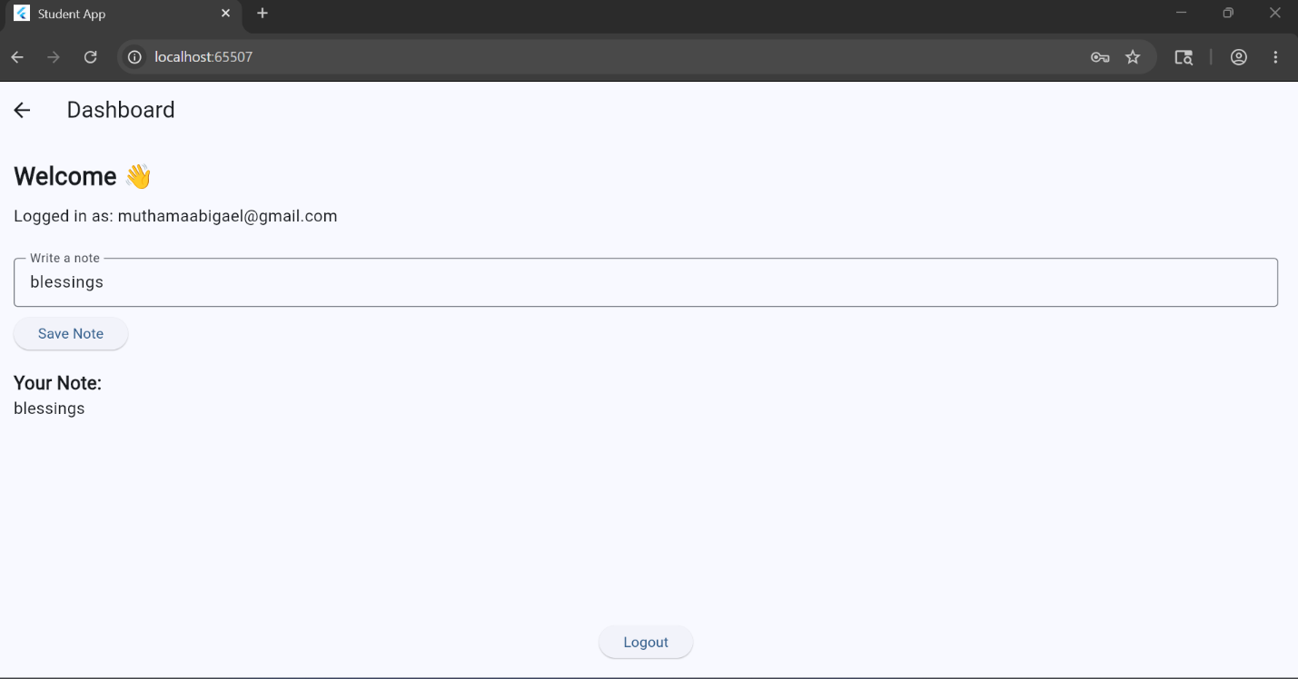

Tools/Software Used
    - Flutter
    - Chrome

Personal Reflection
During the second week, I applied the concepts learned in class to design and develop my first mobile application, a simple task management app. Building the application helped me better understand Flutter widgets, layouts, navigation, and user interaction. Seeing the app function successfully was a rewarding experience that improved my coding skills, boosted my confidence, and motivated me to continue learning mobile application development.

Week 3: User Interface Design

Designing in FIGMA
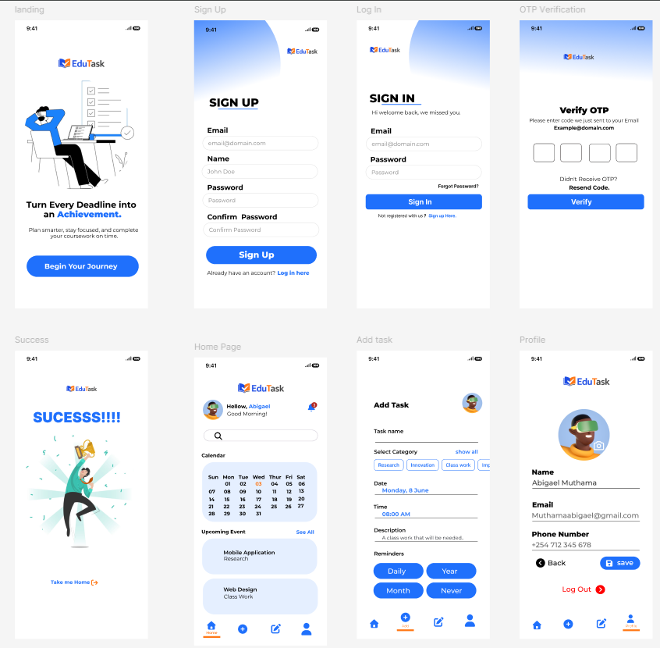

Data flow within the design
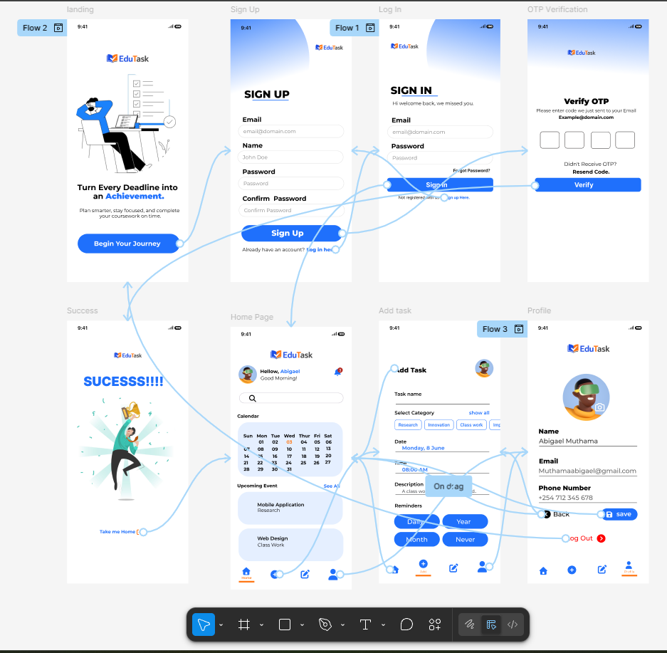

Tools/Software Used
- FIGMA
- FLUTTER
- CHROME
- ADROID STUDIO

Project coding and implementation screenshots
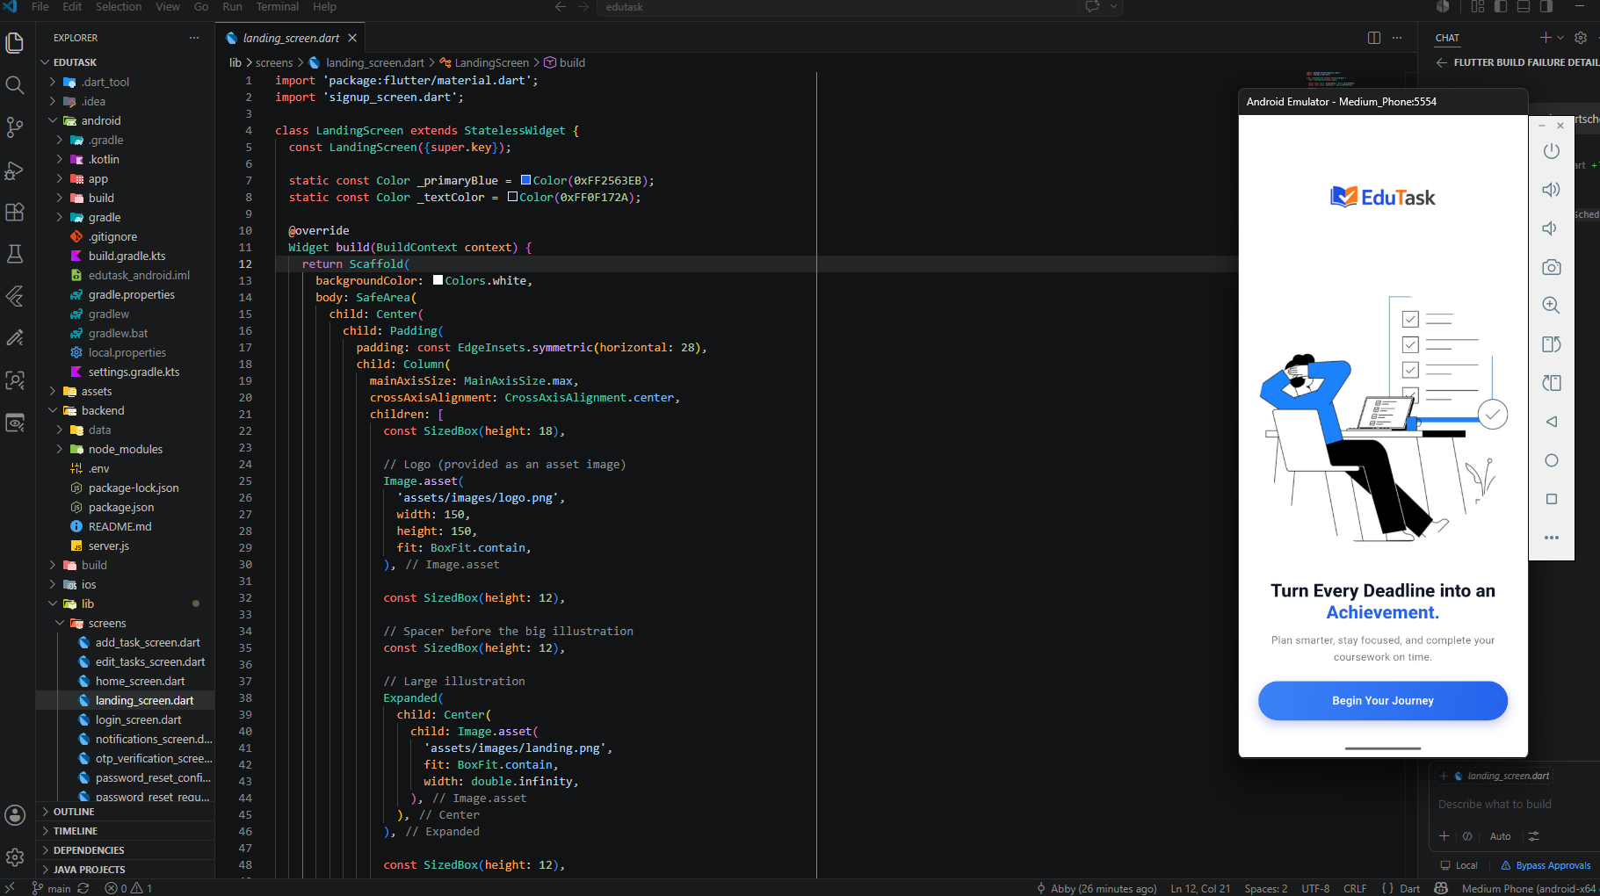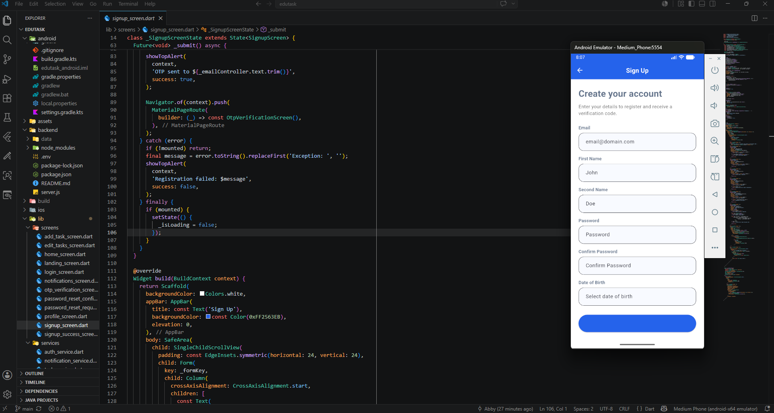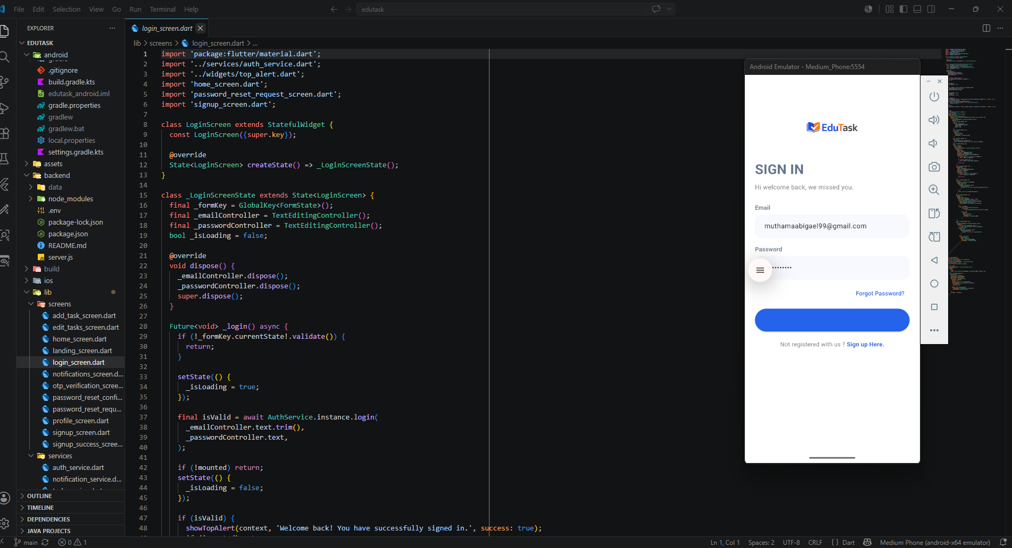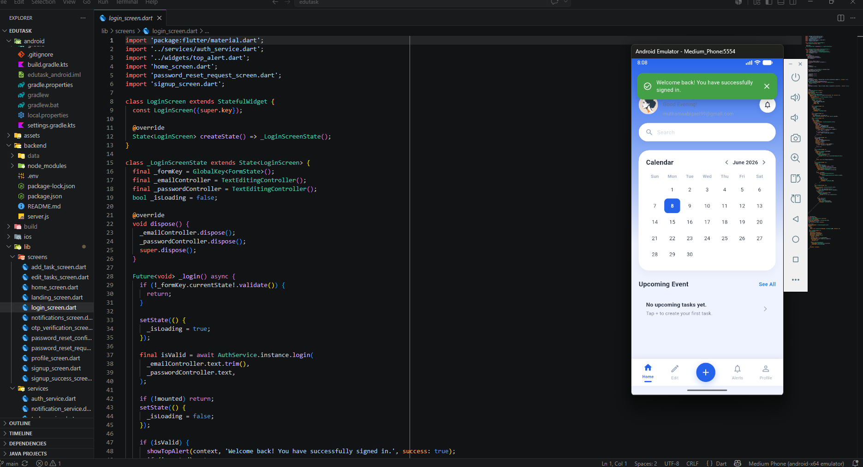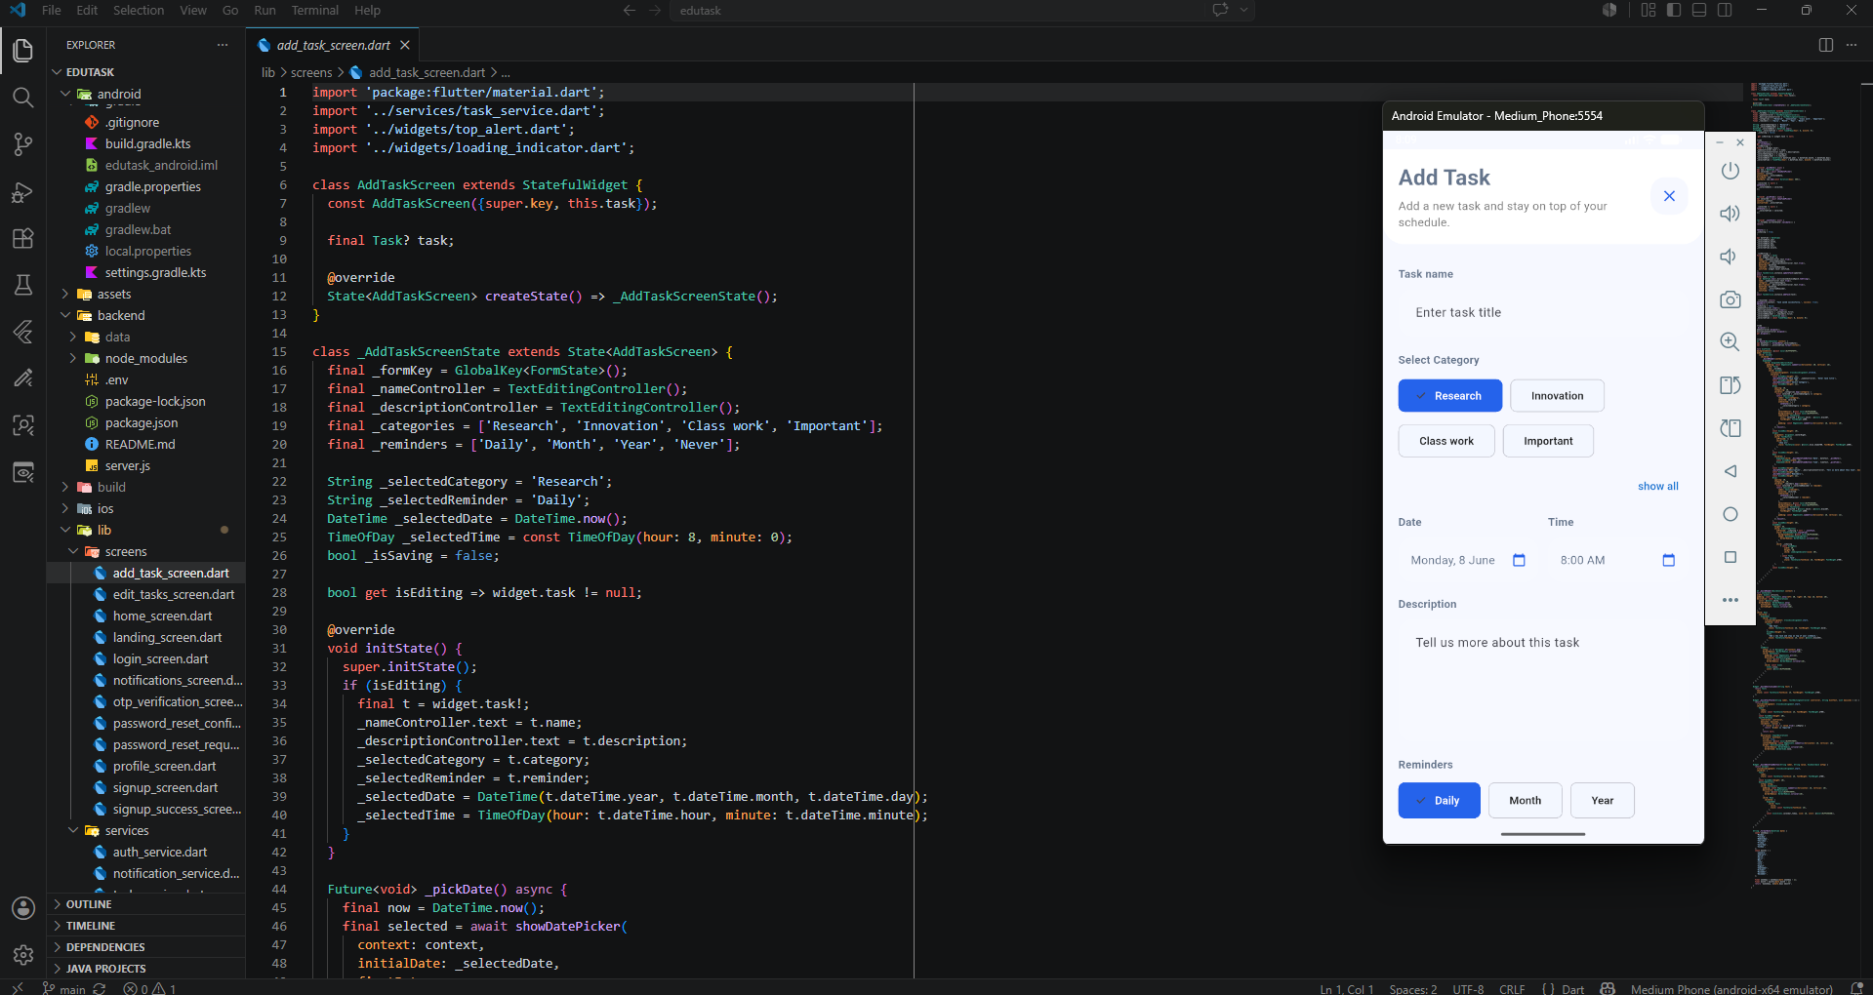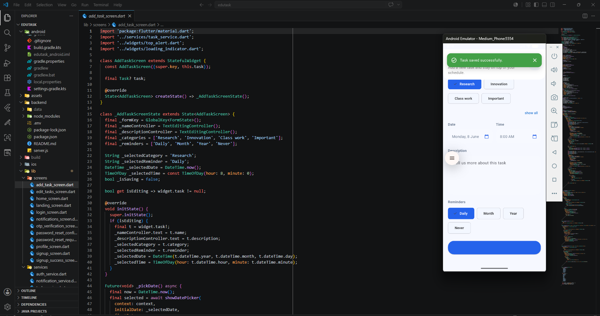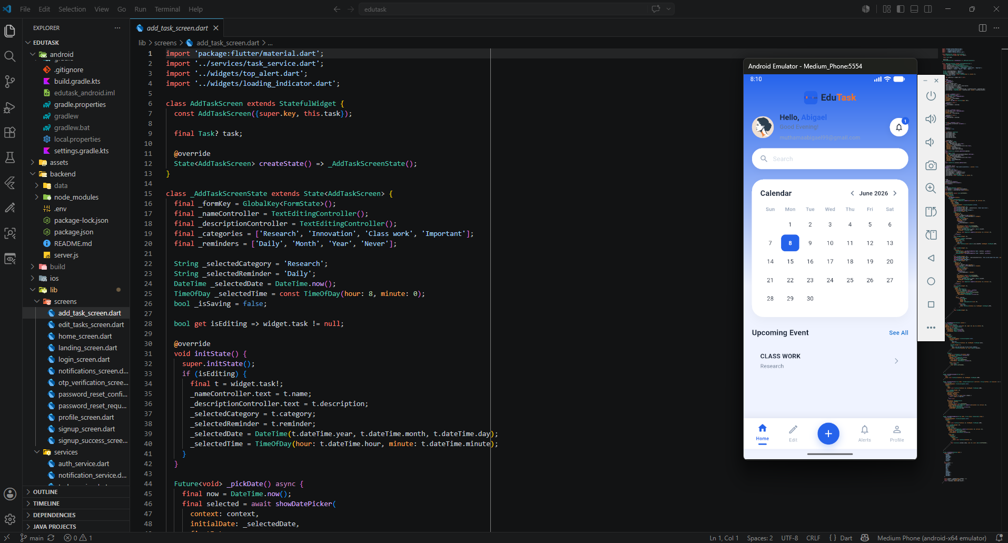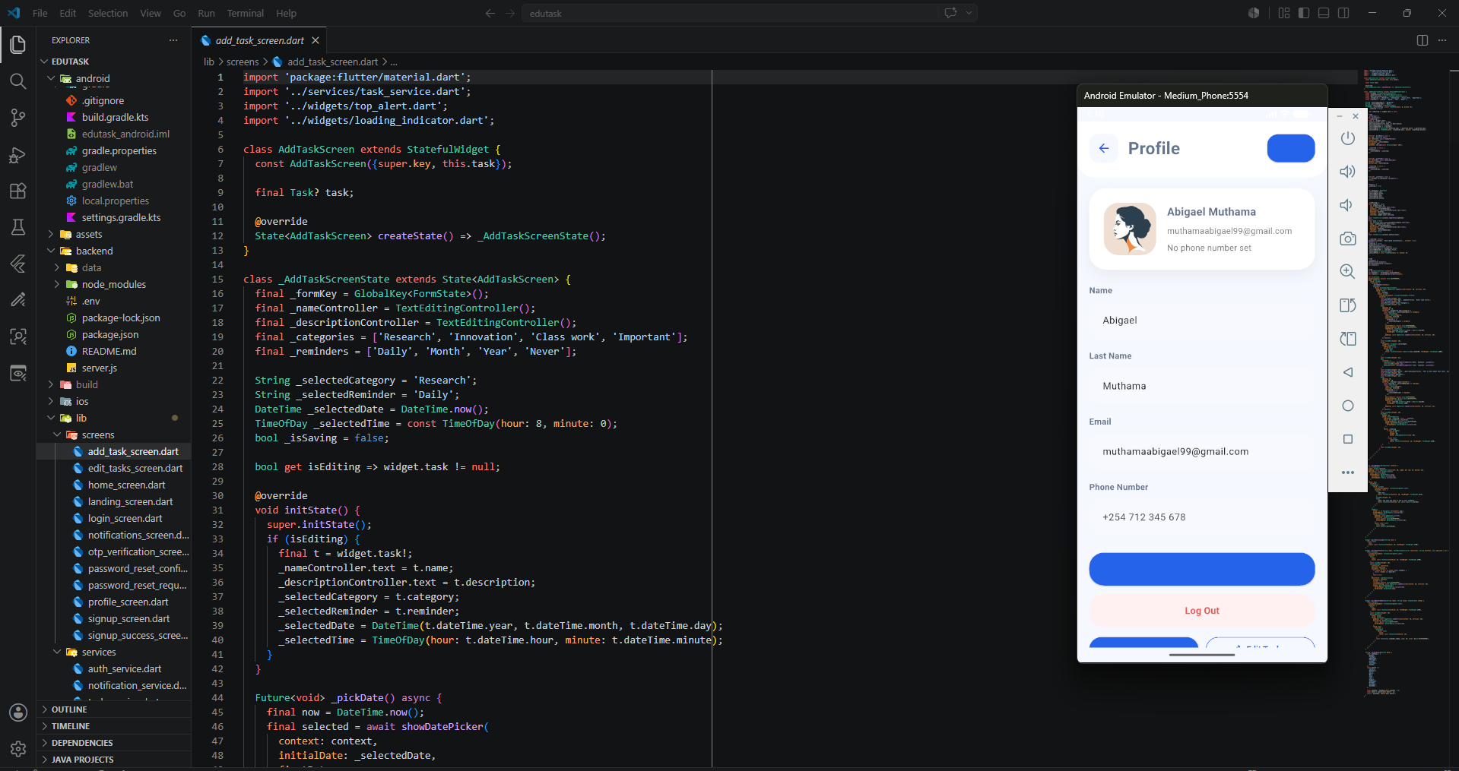

Personal Reflection
Week three introduced me to the integration of UI/UX design and mobile application development using Figma and Flutter. I used Figma to create and prototype application interfaces before implementing them in Flutter. Android Studio and Chrome were essential for testing, debugging, and previewing the application across different platforms. This experience enhanced my understanding of the software development workflow, improved my design thinking, and strengthened my ability to transform visual designs into functional mobile applications.

